# CS 255 System Design Document Template

This template lays out all the different sections that you need to complete for Project Two. Each section has guidance to prompt your thinking. You will need to continually reference the interview transcript as you work to make sure that you are addressing your client’s needs. There is no required length for the final document. Instead the goal is to complete each section based on what your client’s needs are. Remove this note when you are finished, and replace all bracketed text with the relevant information.

## UML Diagrams

### UML Use Case Diagram

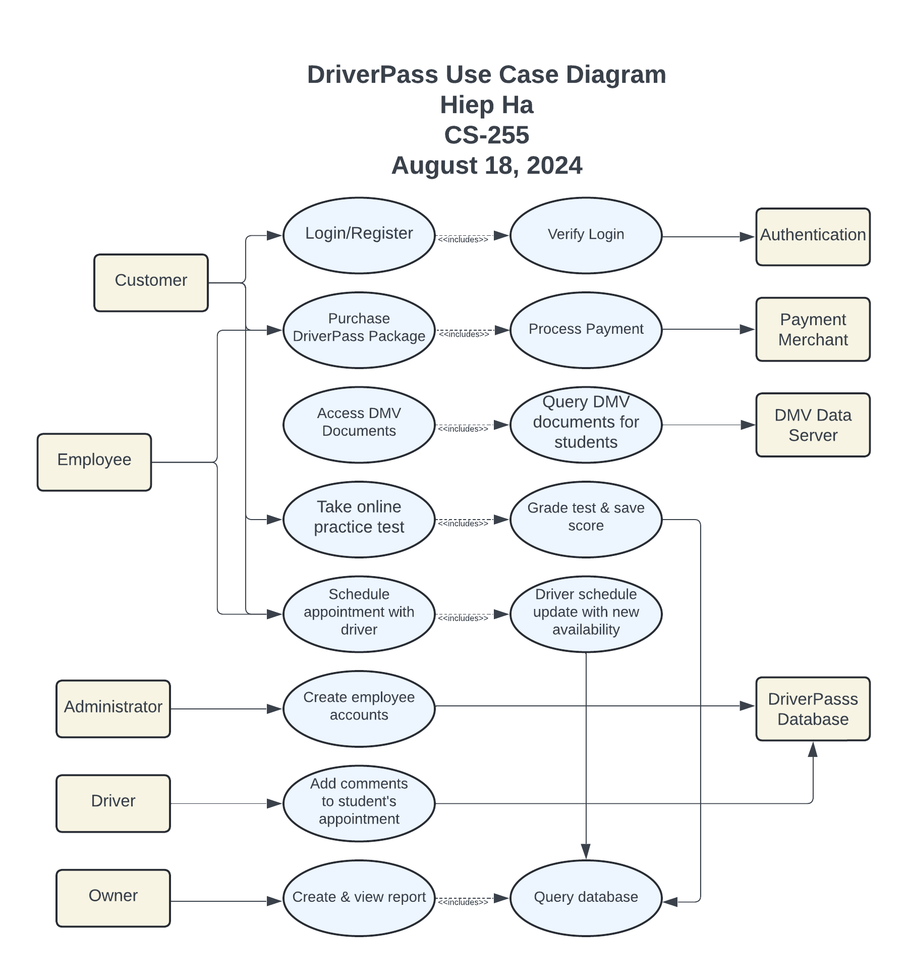

### UML Activity Diagrams

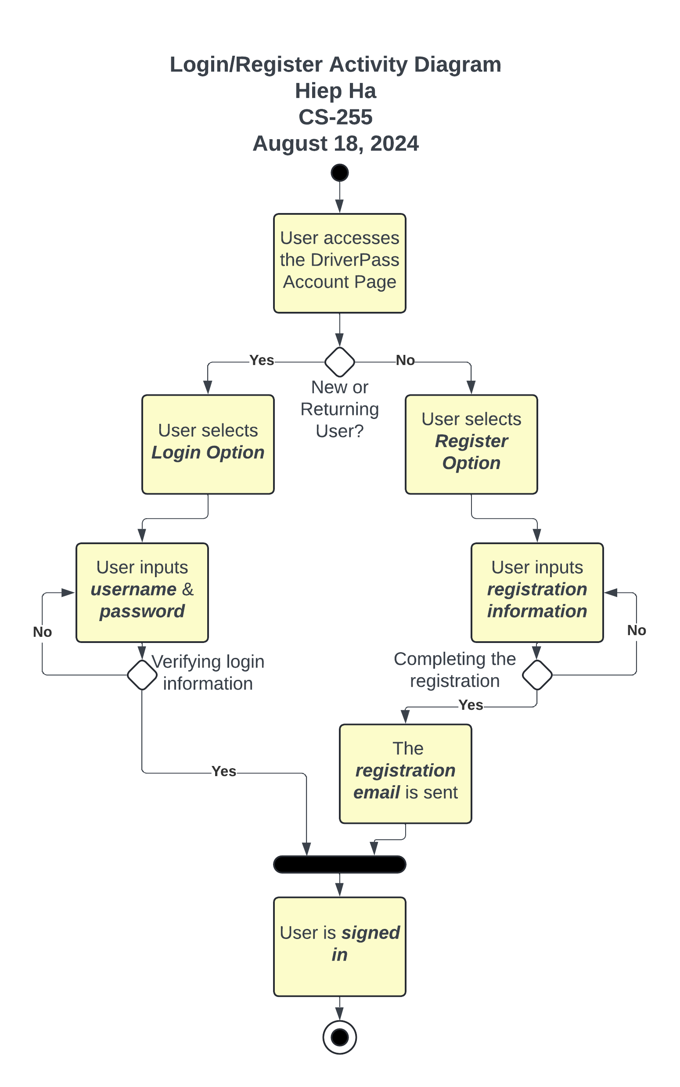

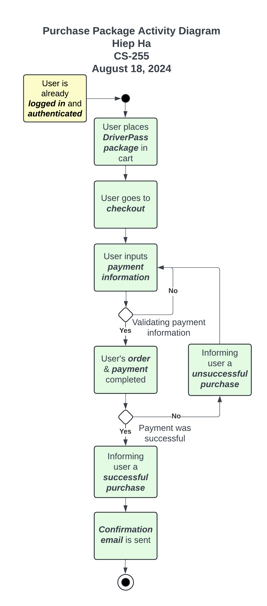

### UML Sequence Diagram

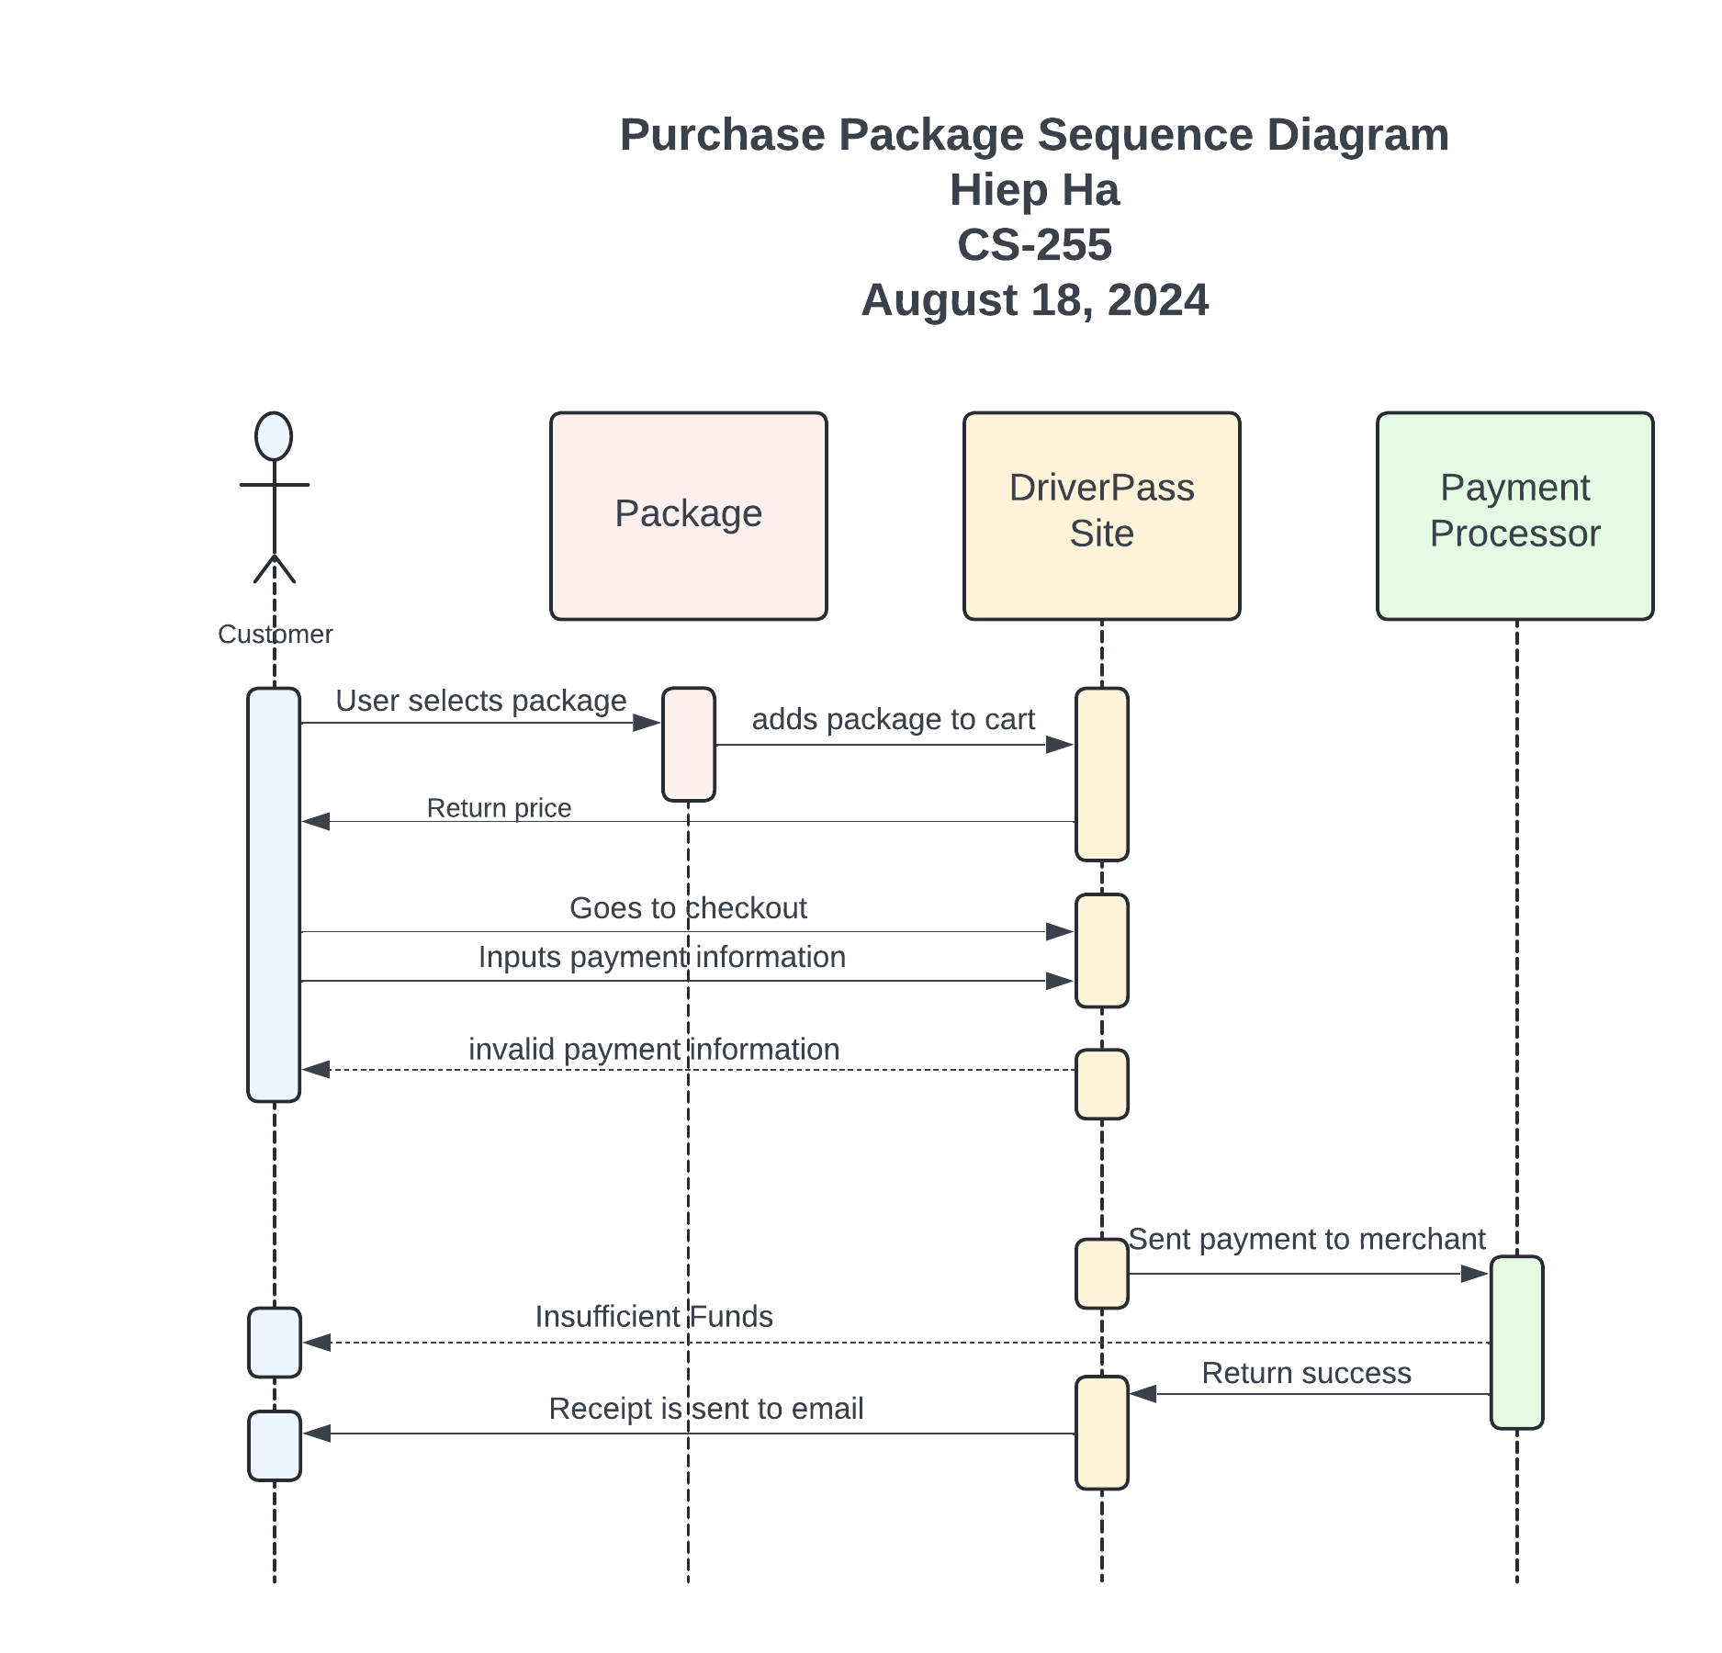

### UML Class Diagram

## Technical Requirements

***Hardware:***

* *Dedicated server*
* *Reliable internet connection*
* *Storage for database and website content*
* *Computer or mobile device for user access to the website*
* *Firewall to safeguard website ports*

***Software:***

* *Recommended: Windows Server (latest stable version)*
* *Recommended: SQL Server for database management (latest stable version)*
* *Backup software for website and database protection*
* *Web server software such as Apache*
* *Security software to guard against malware*

***Geographic Information:***

* *Website should be accessible throughout America*
* *Website and database servers should be housed in a secure data center*
* *Server should be located centrally*